# **Refer ArrayList.java**

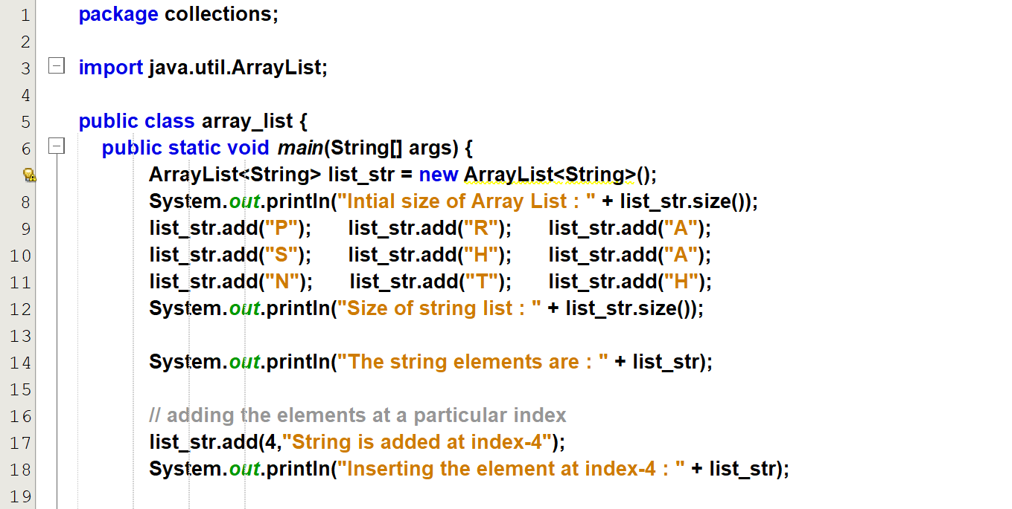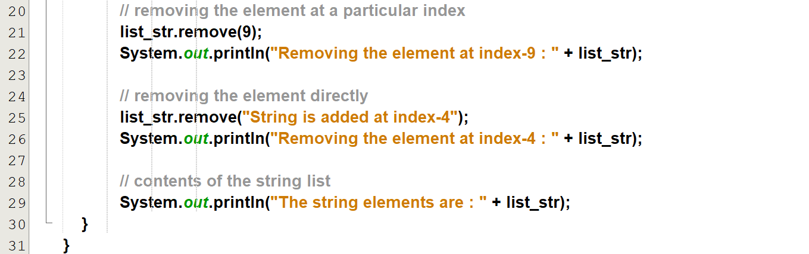

Output:  
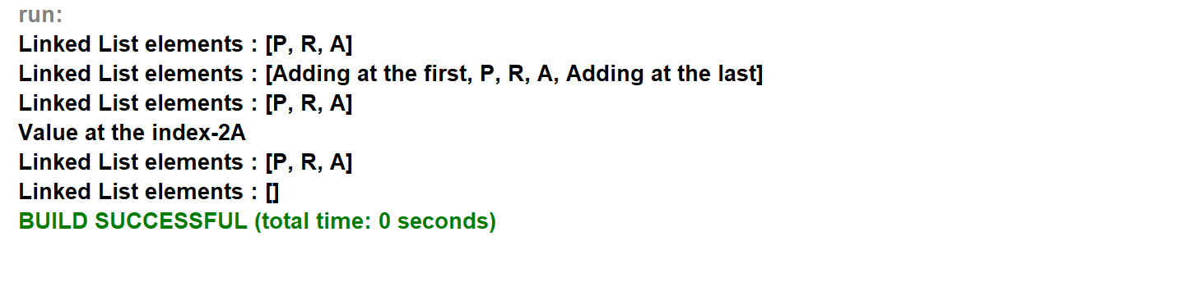

# **Refer copy_clone_ArrayList.java**

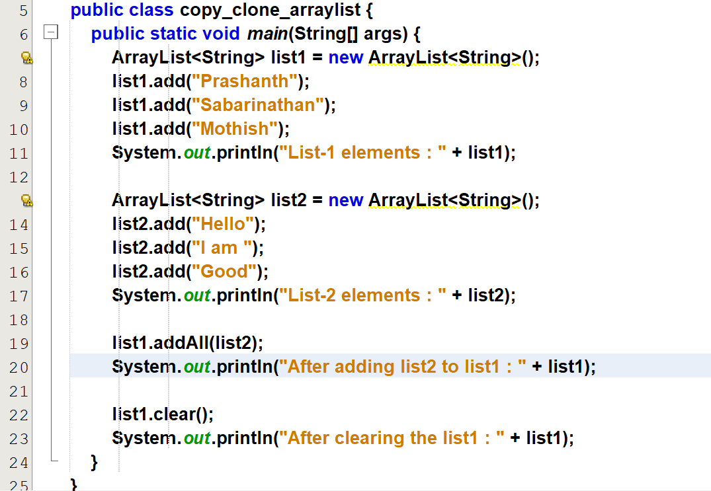

Output:  
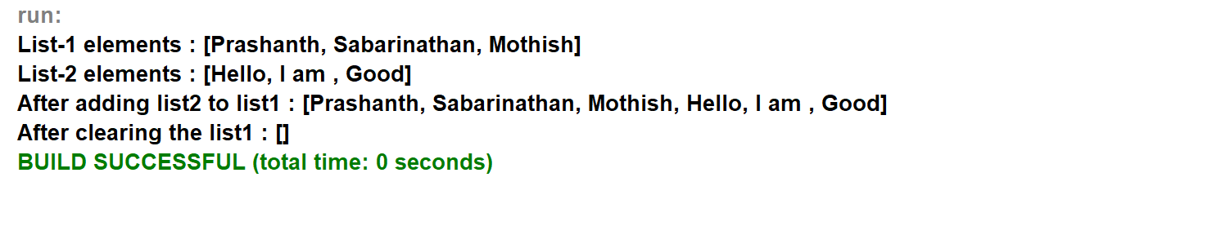

# **Refer contains_all_or_not.java**

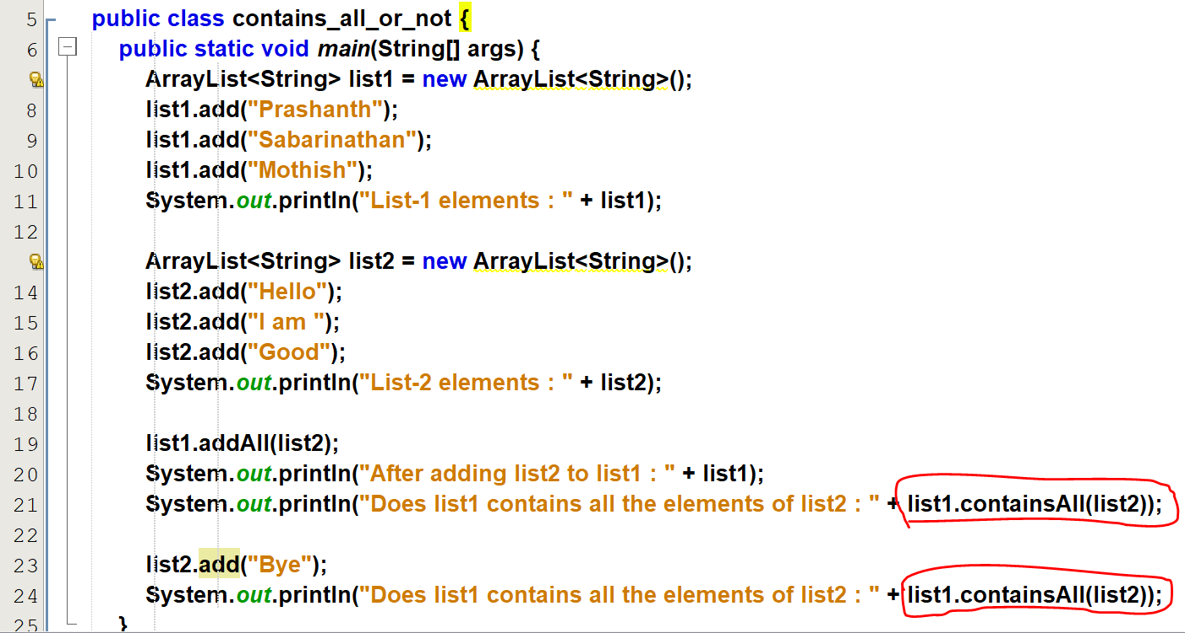

Output:  
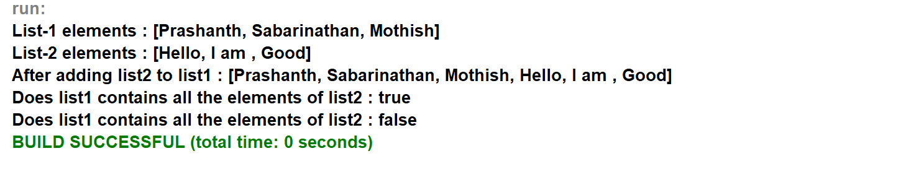

# **Refer arraylist_to_array.java**

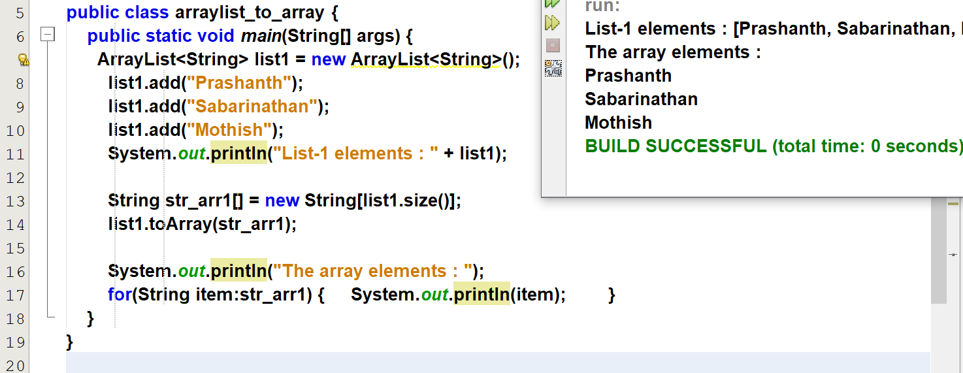

# **Refer swap_two_elements.java**

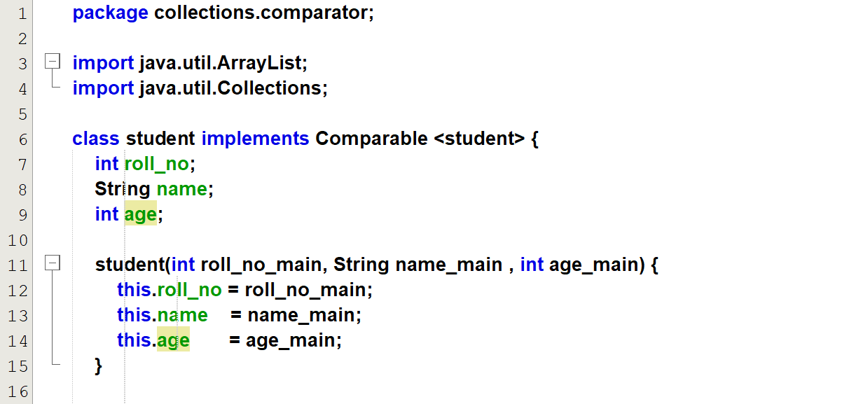  
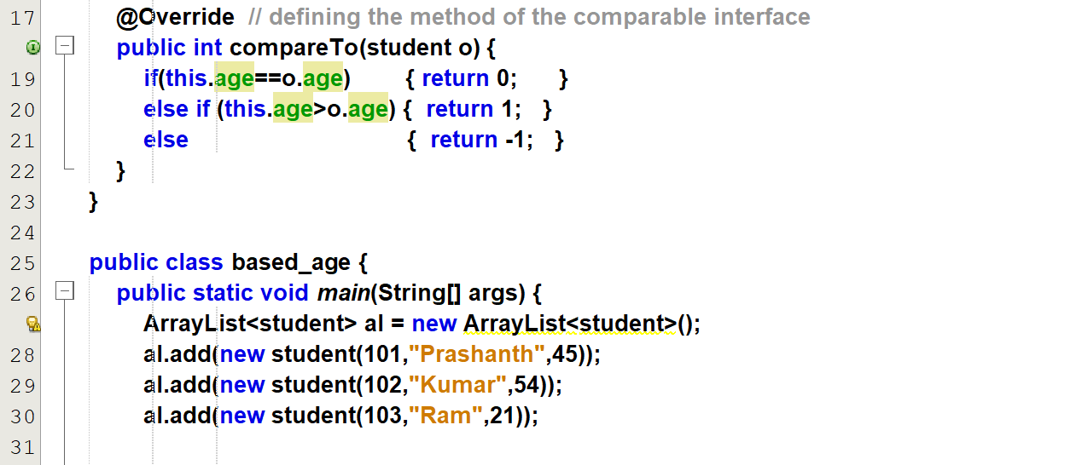  
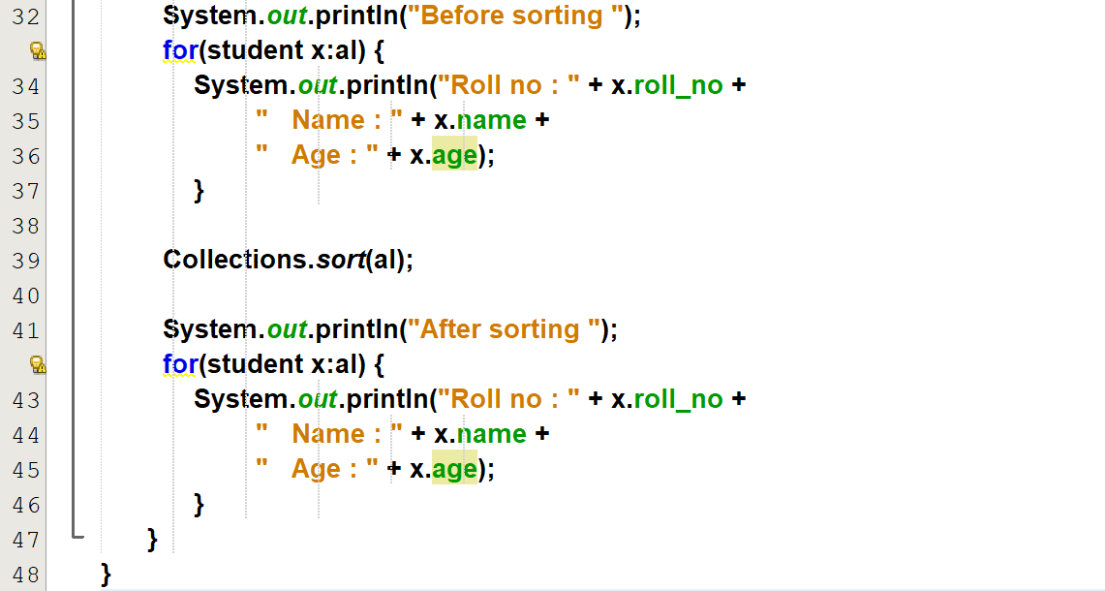

Output:  
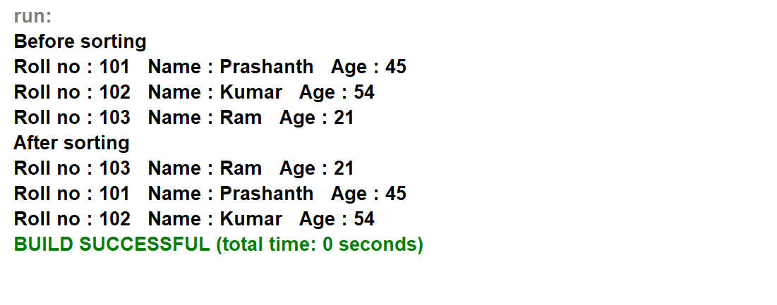

# **Refer linked_list.java**

Output: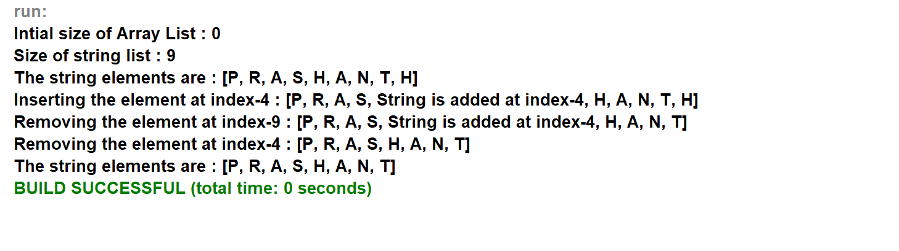

**Refer sub_list_from_ArrayList.java**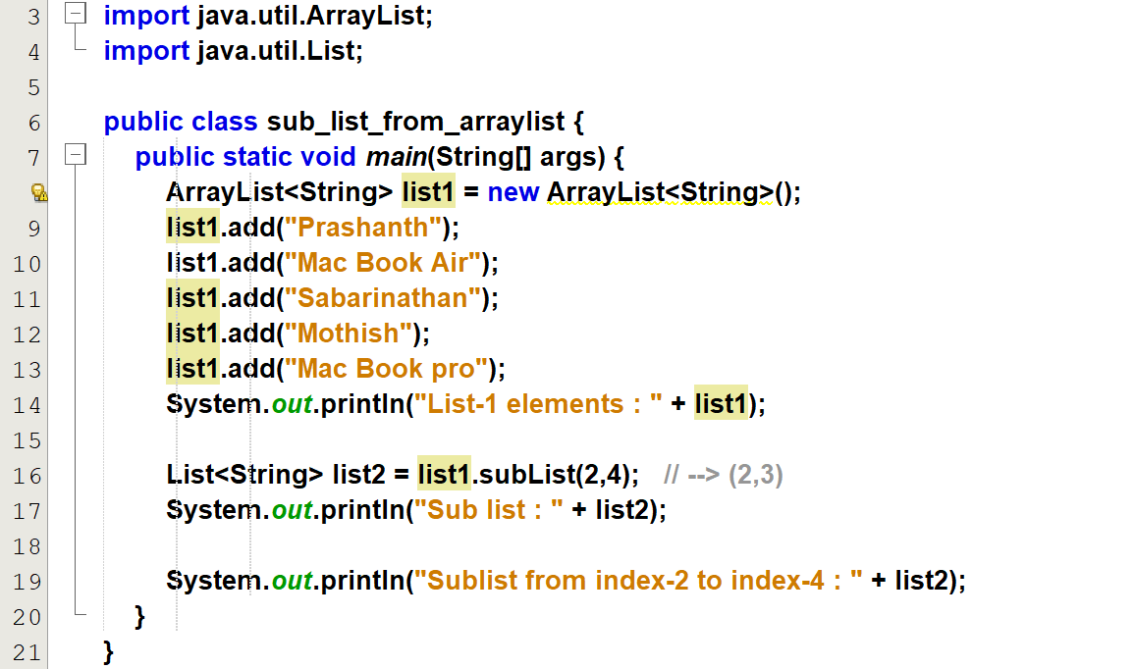

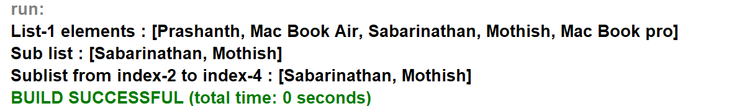

# **Refer tree_set.java**

Output:

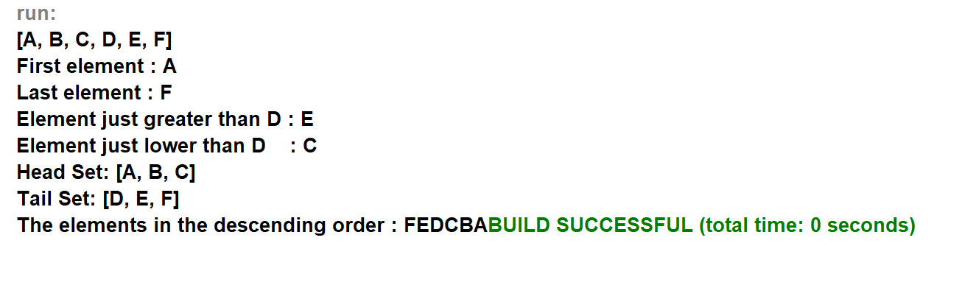

**Refer hash_set.java**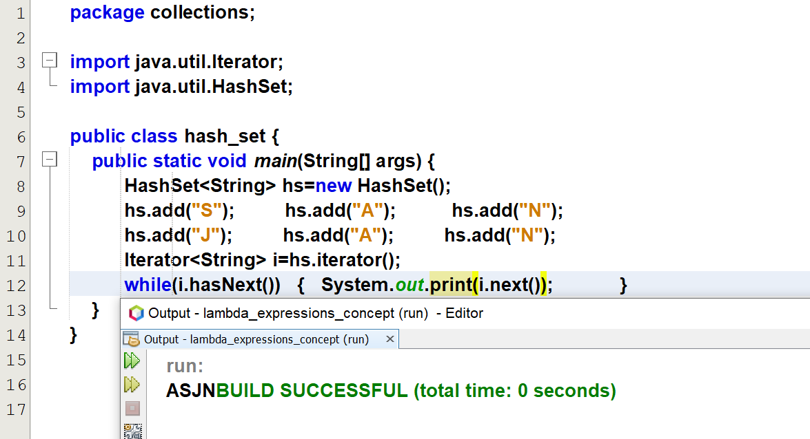

@FunctionalInterface 🡪 A single function inside a interface.

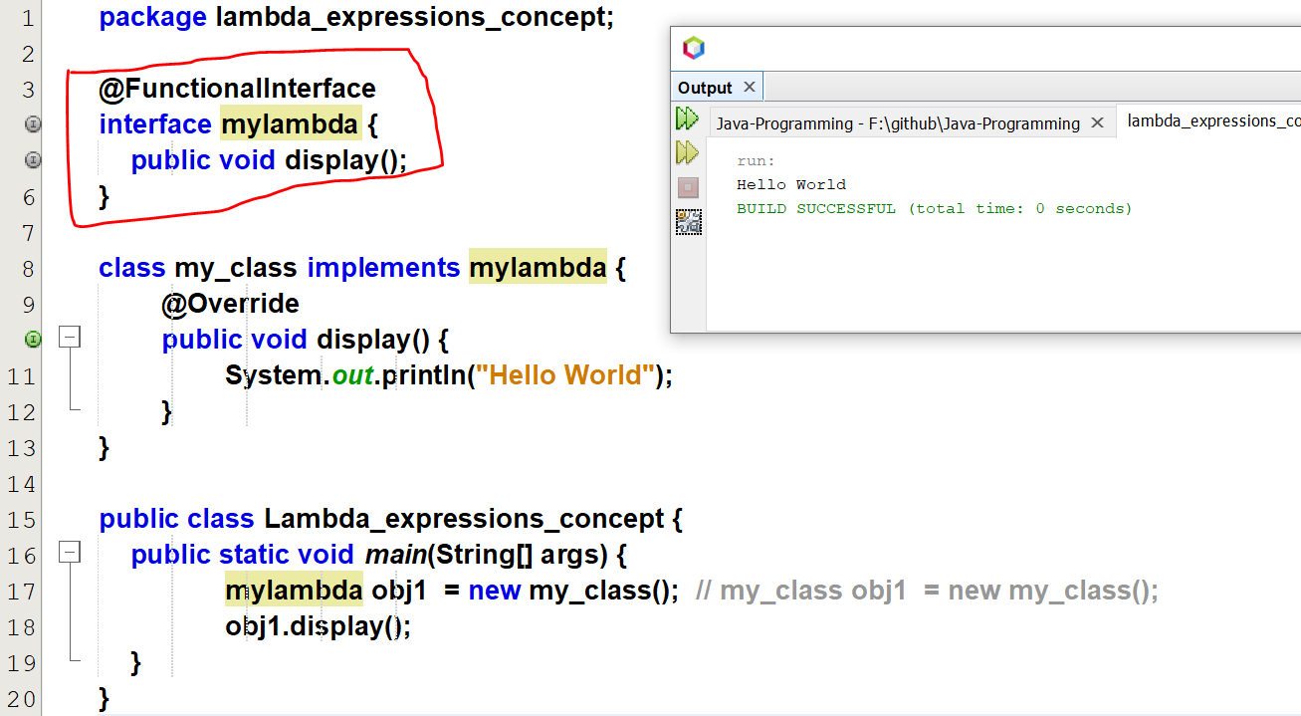

Using anonymous inner class.

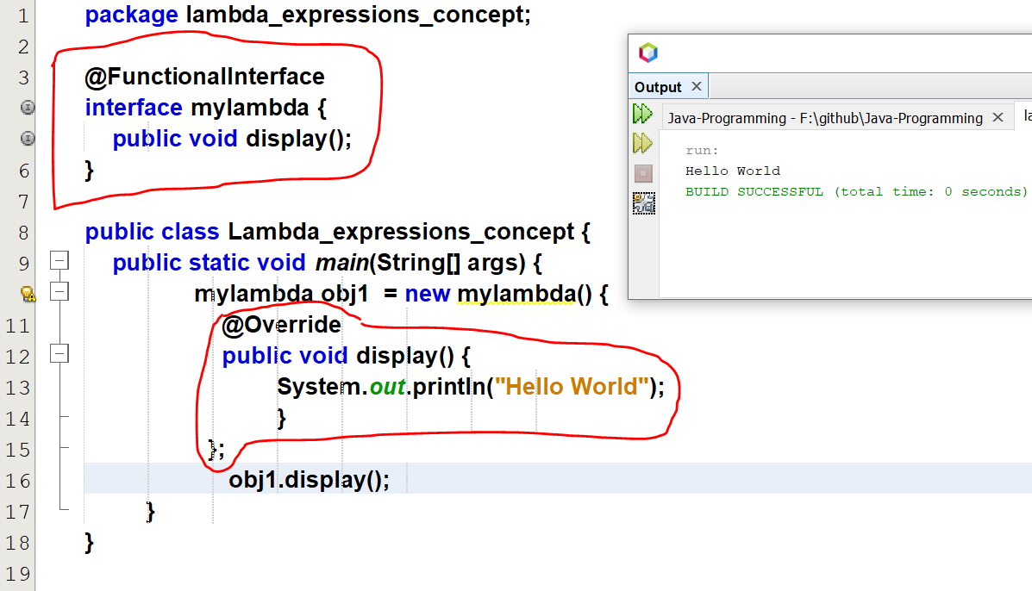

# **Refer Lambda_expressions_intro.java**

Lambda expression

1. No need of right side to equal. ( new mylambda() )
2. No need of method name. ( public void display() )

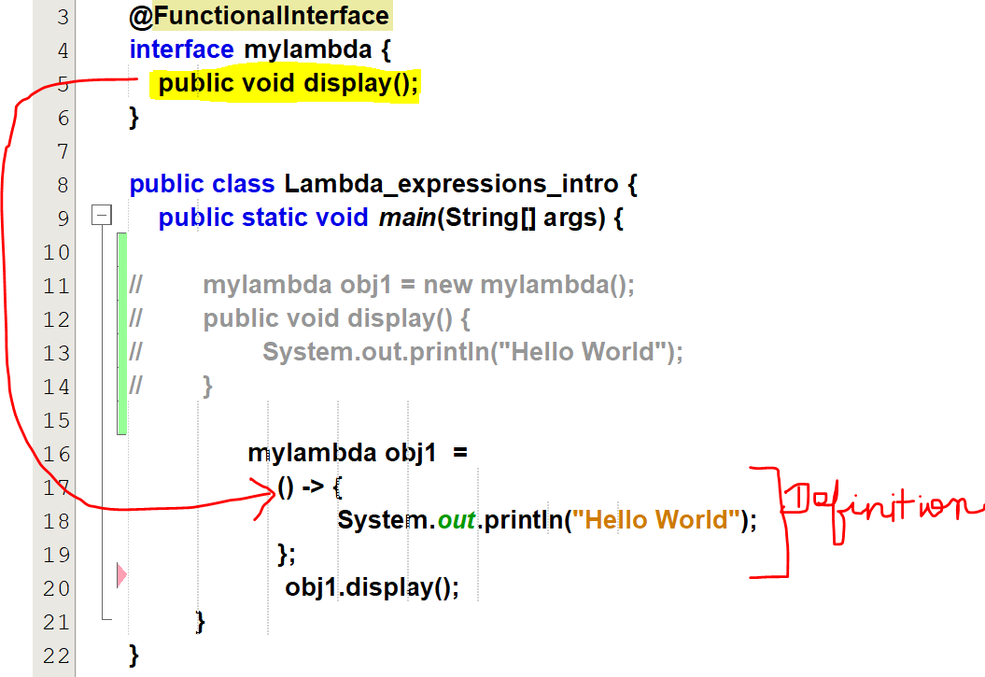

# **Refer single_parameter.java**

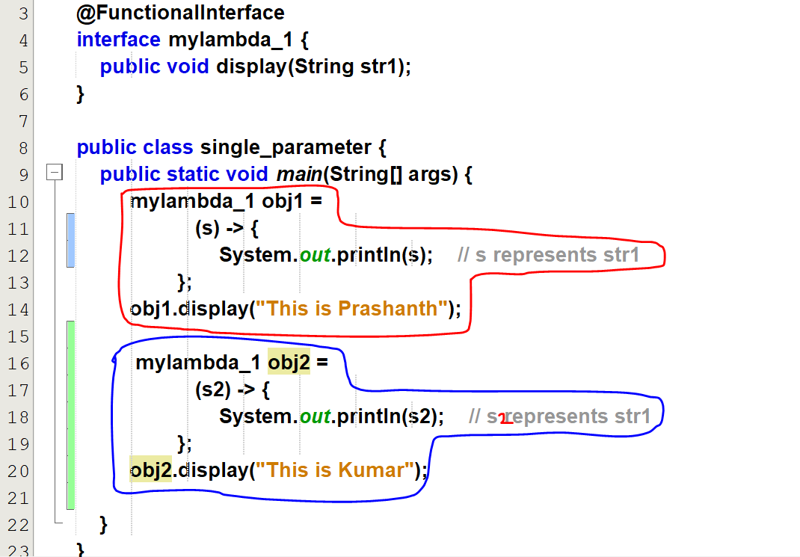

# **Refer multiple_parameters.java**

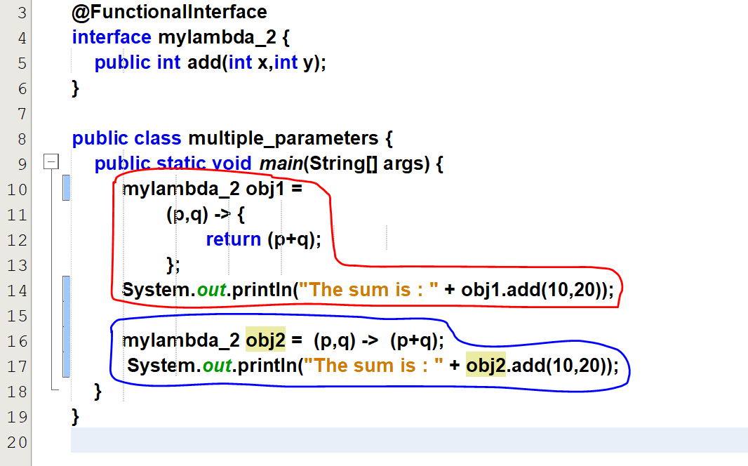

Output:  
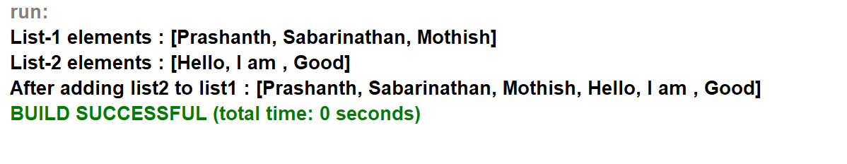

# **Refer exception_handling.java**

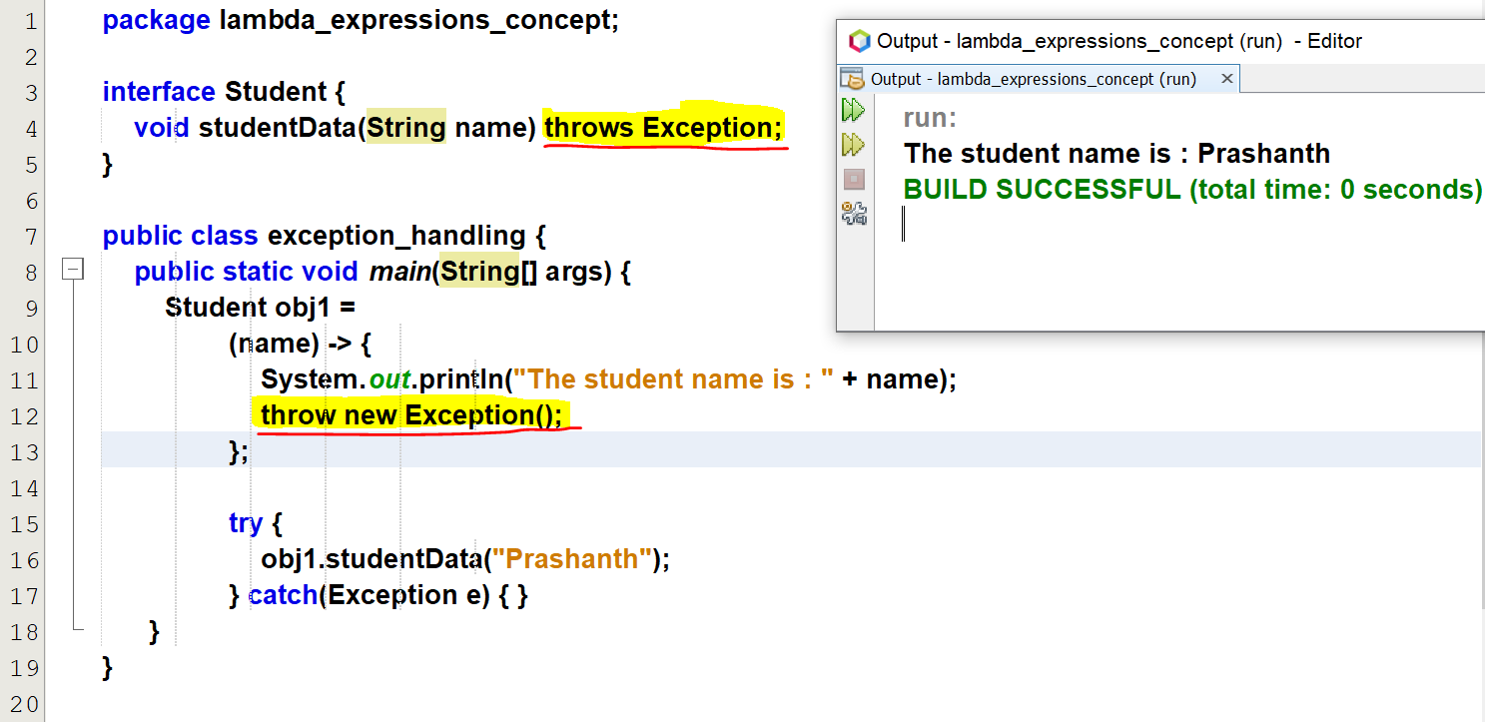

# **Refer captures.java**

A lambda expression can have its own variable and can be accessed within it.

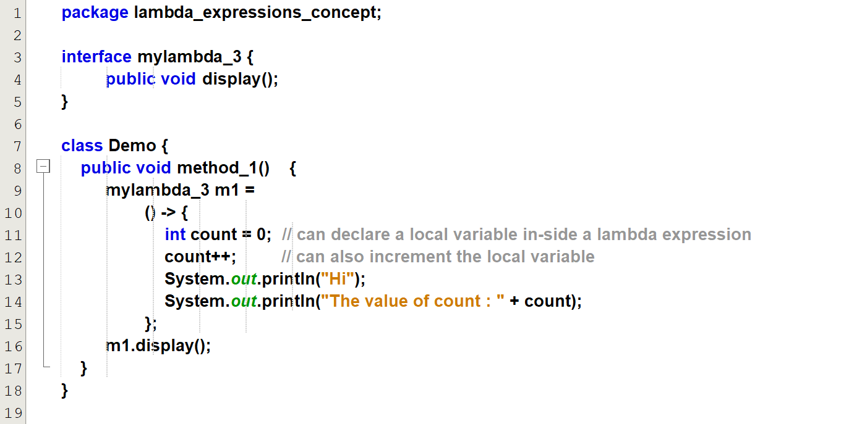  
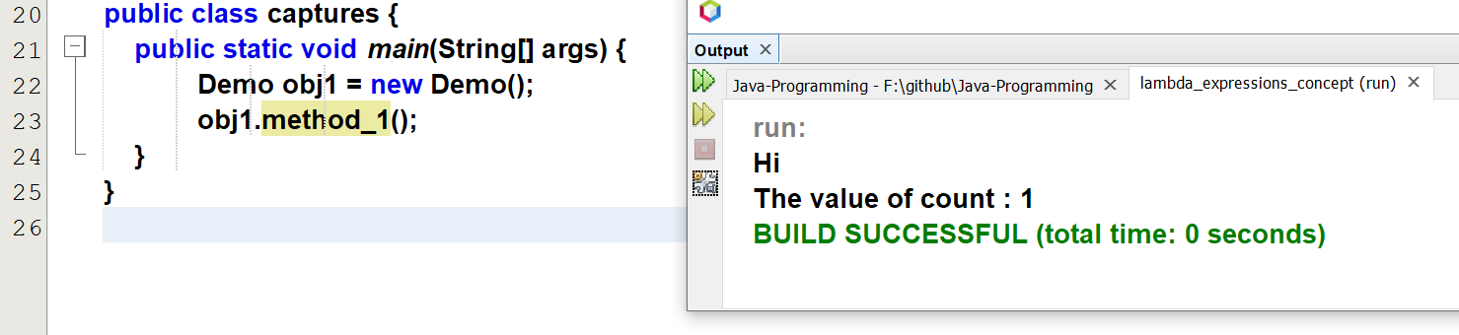

A lambda expression can access the local variable (or) capture the local variable only if they are final / they are never modified inside the method.

A lambda expression can access the variables of a method in which this expression is defined but those variables must be final/effectively final.

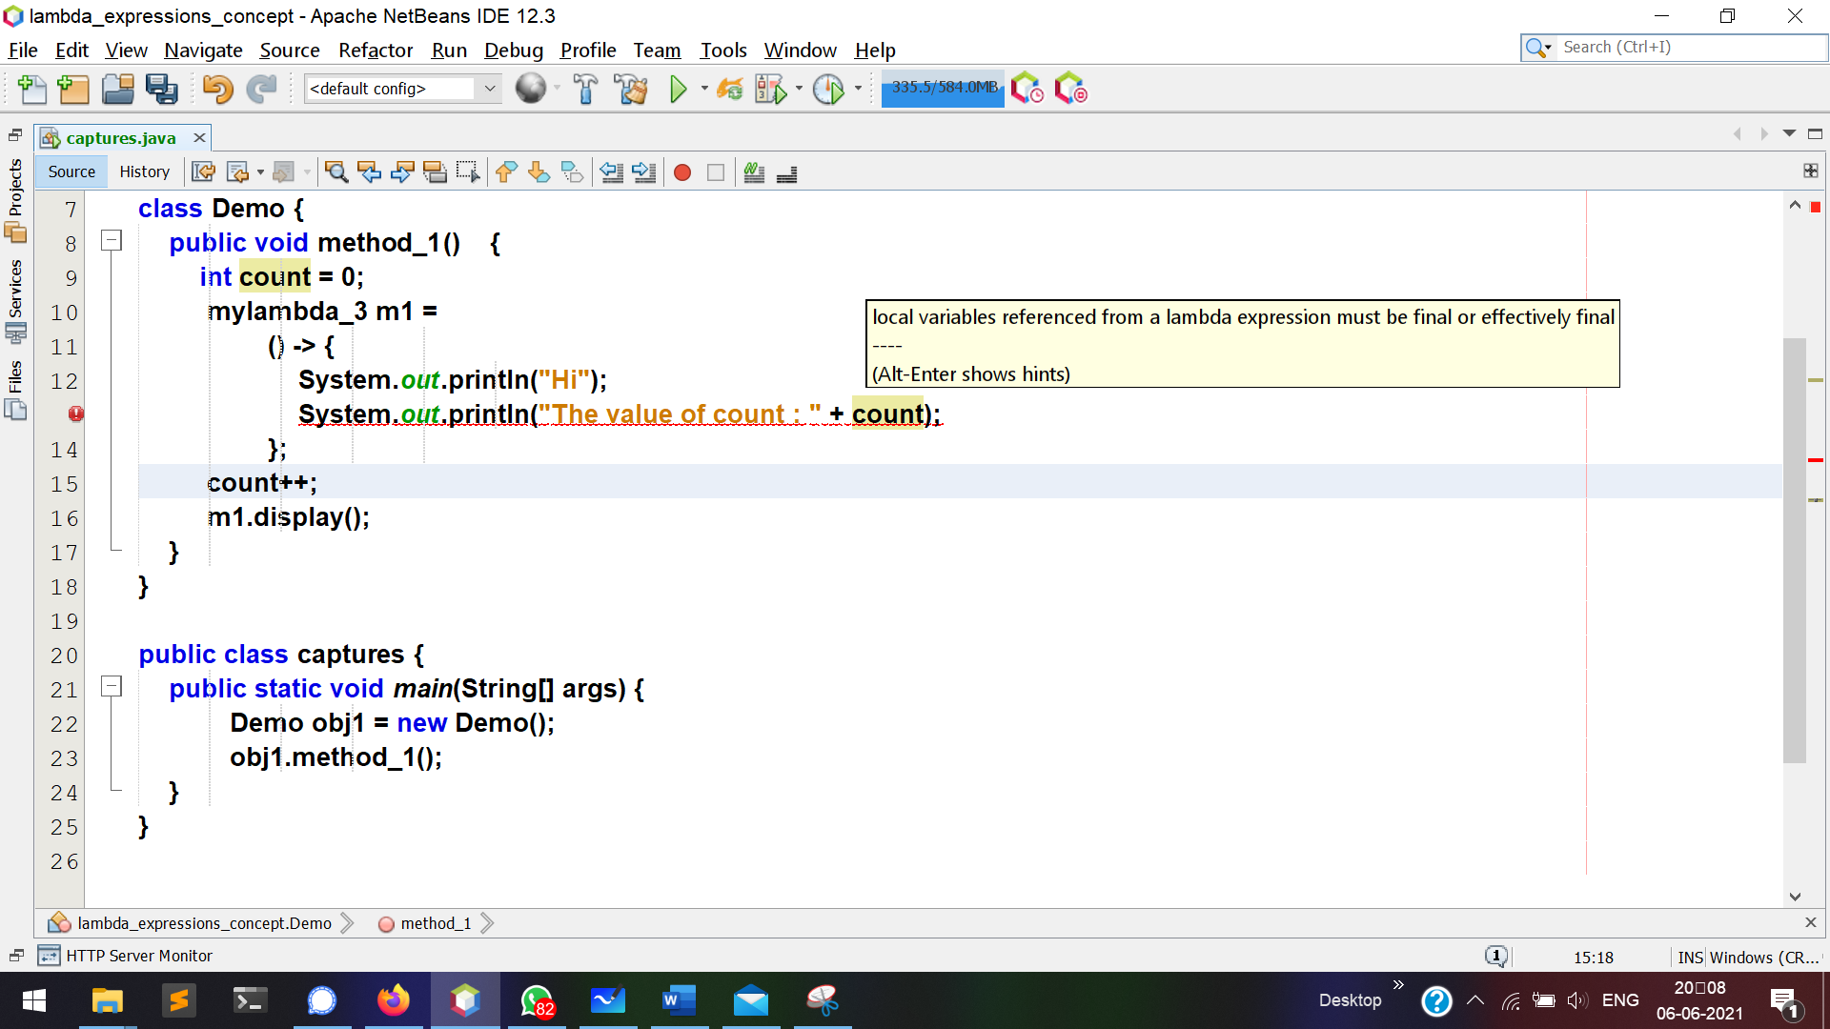

A lambda expression can access/modify the instance variable (i.e temp) , that instance variable may or may not be final.

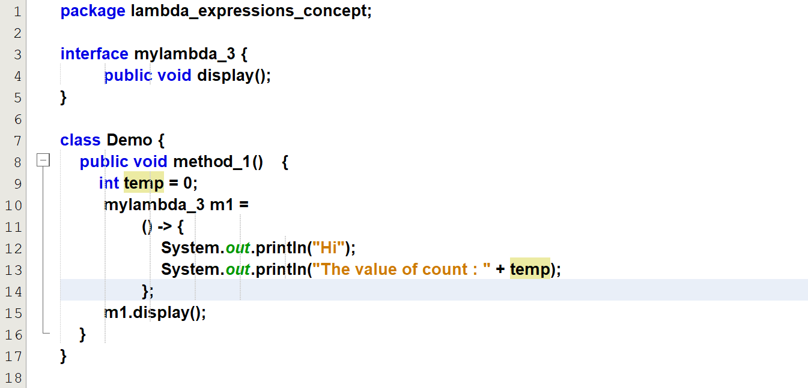  
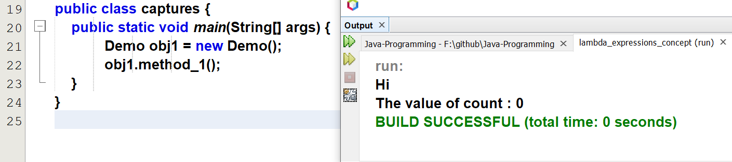

# **Refer lambda_expression_asArguments.java**

